Sales and Profitability Analysis Report

# Introduction

This report presents a detailed analysis of sales and profitability metrics for key cities. The analysis aims to provide insights into the sales performance and profitability levels in these cities, which can be invaluable for strategic decision-making.

# Methodology

The analysis is based on historical sales data, including parameters like total sales, costs, and profits. Key cities were identified based on total sales, and profitability metrics such as profit margin were calculated. The results are presented in both tabular and graphical formats for comprehensive understanding.

# Sales and Profitability Analysis

The table below shows the key metrics for the top 10 cities based on total sales:

|  |  |  |  |  |
| --- | --- | --- | --- | --- |
| City | Total Sales | Total Cost | Total Profit | Profit Margin (%) |
| New York City | 27205.46 | 5841.85 | 21363.61 | 78.53 |
| Columbia | 47668.78 | 16714.51 | 30954.27 | 64.94 |
| Bowling Green | 27205.29 | 10088.45 | 17116.84 | 62.92 |
| Buffalo | 30042.59 | 11294.28 | 18748.31 | 62.41 |
| Durham | 30048.39 | 11384.9 | 18663.49 | 62.11 |
| Charlotte | 40642.15 | 16141.56 | 24500.59 | 60.28 |
| Mount Pleasant | 37463.86 | 15193.02 | 22270.84 | 59.45 |
| Miami | 31929.83 | 13001.08 | 18928.75 | 59.28 |
| Owensboro | 32513.17 | 13831.19 | 18681.98 | 57.46 |
| Louisville | 37227.42 | 16606.39 | 20621.03 | 55.39 |

The graph below provides a visual representation of both sales and profitability metrics for these key cities:

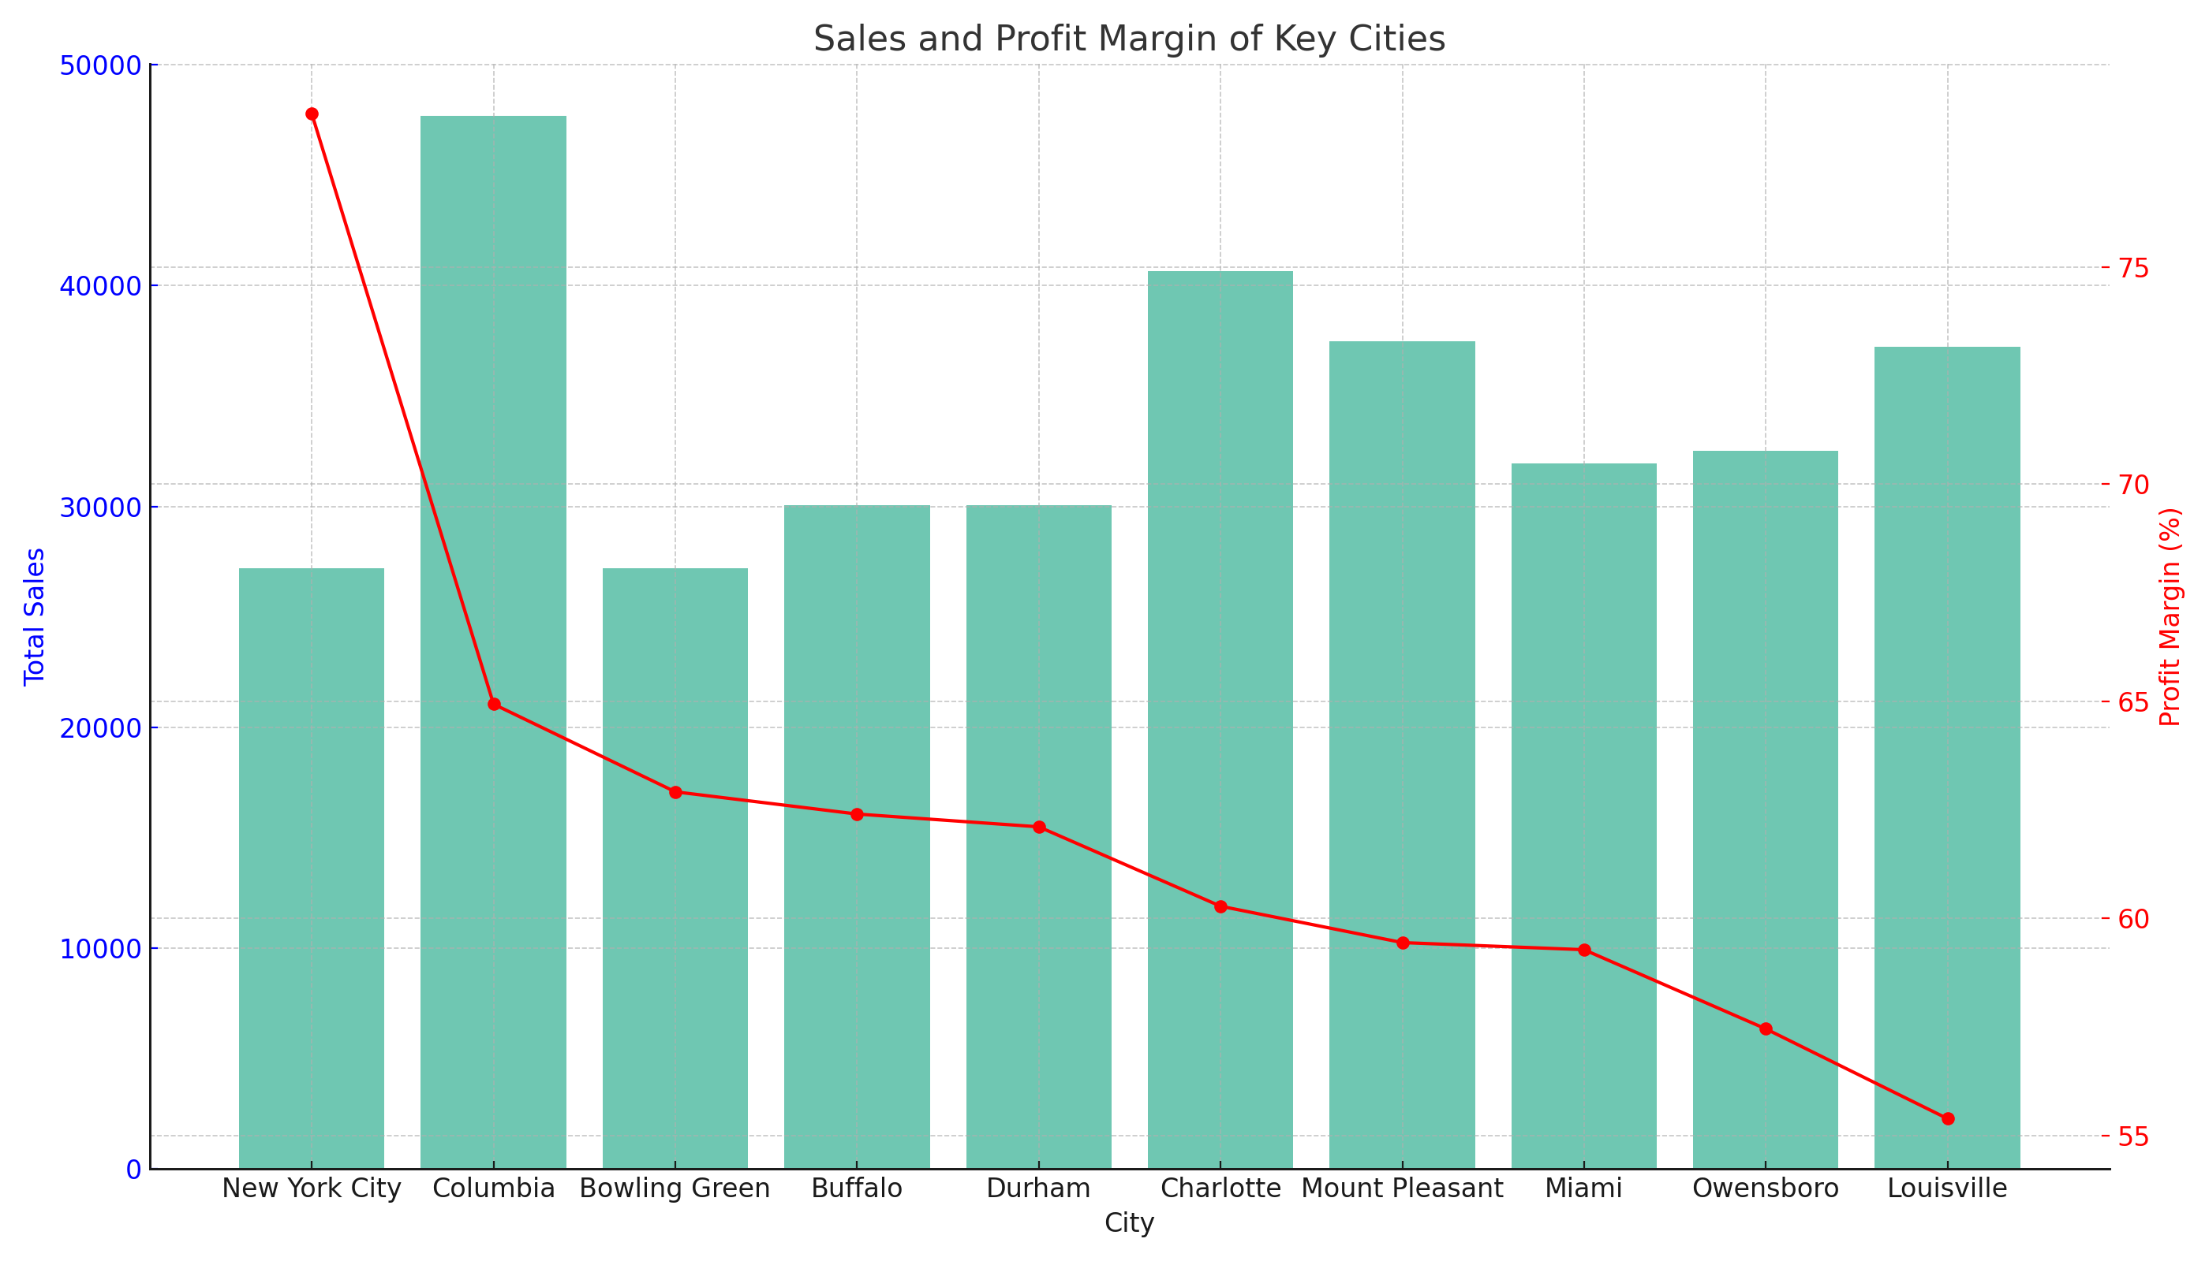

# Conclusion

The report offers a detailed analysis of sales and profitability for key cities. Cities like New York City show high profitability despite lower total sales, while cities like Louisville, although having high total sales, show the lowest profit margin. Such insights can guide strategic business decisions.

# Probability of Repeat Purchase Analysis

This section presents an analysis to estimate the probability that a customer will make a repeat purchase in the next three months. The analysis is based on the frequency of purchases made by each unique customer during the last three months.

## Methodology

The probability of a repeat purchase was calculated using the following formula:

Probability of Repeat Purchase (%) = (Number of Customers with at least one repeat purchase in the last 3 months / Total Number of Unique Customers) × 100

## Findings

The probability that a customer will make a repeat purchase in the next three months is approximately 52.0%.

## Conclusion

The analysis indicates that there is a 52% chance that a customer will make a repeat purchase within the next three months based on historical data. This information can be useful for planning customer retention strategies.